EXPERIMENT – 8
Perform basic Image Handling and Processing Operations: Read an Image in Python and Dilate an Image Using the Dilate Function
Aim
To read an image using Python and OpenCV and apply image dilation using the cv2.dilate() function.
Procedure
- Import the OpenCV library.
- Read the input image using cv2.imread().
- Check whether the image is loaded successfully.
- Create a kernel using numpy.ones().
- Apply dilation using cv2.dilate().
- Display the original and dilated images.
- Wait for a key press and close all image windows.
Program

Sample Input
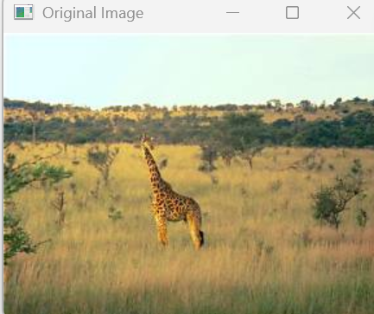
Sample Output
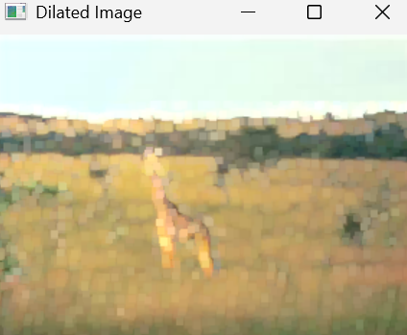

- Dilated image with expanded bright regions and thicker features.
Result
Thus, the image was successfully read and dilation was applied using Python and OpenCV.

